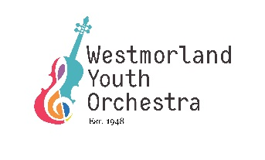
Small Group Music Fund
Application Form
Name of contact: Click or tap here to enter text.
Position: Click or tap here to enter text.
Address: Click or tap here to enter text.
E-mail: Click or tap here to enter text.
Phone number: Click or tap here to enter text.

About your group:
Which instruments does your group play? Click or tap here to enter text.
What kind of music do you perform? Click or tap here to enter text.
How many children are involved? Click or tap here to enter text
What is the age range? Click or tap here to enter text.
Are you associated with a school or music school and if so which one? Click or tap here to enter text.
Is there any other useful information you would like to tell us? Click or tap here to enter text.

About your request:
How much money are you applying for? Click or tap here to enter text.
Tell us what the money is for, why you need it and how will it help your group? Click or tap here to enter text.
Have you sought funding from any other sources for this project and if so which? Click or tap here to enter text.
In order to consider your application we will require some proof of the costs involved. This will differ depending on what it is for; for sheet music or similar items please send a link to the supplier from which you intend to buy it. For travel costs (such as minibus or coach travel) please send two quotations. If you are in any doubt about what quotations to include please feel to contact the Administrator before submitting your application.

Please submit this application and any accompanying paperwork to admin@wyo.org.uk or by post to The WYO Administrator Johnby Hall Johnby Penrith CA11 0UU

